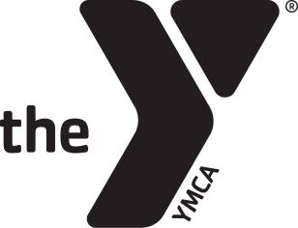

**BLOOMSBURG AREA YMCA**

**Adaptive Recreation Volunteer Application**

Thank you for considering the Bloomsburg Area YMCA as a place to donate your time and talents. Volunteers are vital to the YMCA!

You will find questions on this form about your background, places of employment and so on. We **require** a child abuse clearance, criminal history clearance. It’s just one of the many ways we help protect children and others served by the YMCA.

Today’s Date: Month/Day/Year)

Name:

Address:

City: State: Zip:

Phone: Day: Evening:

Are you a member of the YMCA? (Membership is not required):

Are you 18 years of age or over? Yes or No

(If no, please have your parent or guardian sign the application too.)   
Emergency Contact

Name & Address:

Phone:__________________________________________

Background

Have you ever been convicted of a criminal offense or are registered as a sex

offender? If yes, what, and when was it?

____________________________________________________________

Liability Waiver

I, ______________________________________________________, the undersigned and my immediate family, release the Bloomsburg Area YMCA from any and all personal injuries or property loss or damage incurred by reason of performing volunteer activities at the YMCA

Your signature:

Date:

Parent’s or guardian’s signature (if under 18):

Date:

Why would you like to volunteer for the Adaptive Recreation Program?

Do you have any experience working with children or adults with special needs? If so, what experience do you have?

**Expectations and Responsibilities for Adaptive Recreation:**

* Sessions are Wednesdays from 4:45-6:15, staff/volunteer will help set up before and clean up after class.
* Staff will stay engaged with program and interact with participants.
* Lead, assist, or provide support to staff/volunteers or children during activities.
* Treat children, families, and other volunteers/staff with respect.
* Never leave a child unattended.
* Provide feedback and input on program.
* Be yourself and have fun!

Please attach clearances required to the application. The following are links to the websites to complete the free clearance as a volunteer.

State Criminal History: <https://epatch.state.pa.us/>

Child Abuse History: <https://www.compass.state.pa.us/cwis/public/home>